## VISVESVARAYA TECHNOLOGICAL UNIVERSITY

“Jnana Sangam”, Belagavi-590014



**Mini Project Report on**

## “ONLINE QUIZ APPLICATION”

Submitted to

#### Visvesvaraya Technological University

In the partial fulfilment of requirements for the award of degree

#### Bachelor of Engineering in

**COMPUTER SCIENCE AND ENGINEERING**

Submitted By

|  |
| --- |
| **HARSHITH AR HARSHITH SM** |
| **(4RA22CS032) (4RA22CS034)** |
| **LOHITH SC MANOJ MB** |
| **(4RA22CS054) (4RA22CS057)** |

Under the Guidance of

#### Mrs. HEMALATHA BM

Assistant Professor,

Department of Computer Science & Engineering Rajeev Institute of Technology, Hassan

**RAJEEV INSTITUTE OF TECHNOLOGY DEPARTMENT OF INFORMATION SCIENCE AND ENGINEERING**

**HASSAN-573201**

**2024-25**

# RAJEEV INSTITUTE OF TECHNOLOGY,

**HASSAN**

**(Approved by AICTE, New Delhi and Affiliated to VTU, Belagavi.)**

**Plot #1-D, Growth Centre, Industrial Area, B-M Bypass Road, Hassan – 573201 Ph:(08172)-243180/83/84 Fax:(08172)-243183**



**Department of Computer Science and Engineering**

# CERTIFICATE

Certified that the **Mini Project entitled “Expenses Management for Financial Stability”** is carried out byMr.HARSHITHAR[4RA22CS032]Mr.HARSHITHSM[4RA22CS034]Mr.LOHITHSC[4RA22CS054] and Mr. MANOJ MB[4RA22CS057] respectively, the bonafide students of **RAJEEV INSTITUTE OF TECHNOLOGY**, Hassan in partial fulfilment for the award of **BACHELOR OF ENGINEERING** in  **COMPUTER SCIENCE AND ENGINEERING** of the Visvesvaraya Technological University, Belagavi during the year 2023-2024. The mini project report has been approved as it satisfies the academic requirements in respect of mini project work prescribed for the said degree.

|  |  |  |
| --- | --- | --- |
| _  **Mrs. HEMALATHA BM** | **Dr. ARJUN BC** | **Dr. MAHESH P K** |
| Assistant Professor | Head of the Department | Principal |
| Dept. of Computer Science &  Engineering | Computer Science & Engineering  **RIT, HASSAN** | **RIT, HASSAN** |
| **RIT, HASSAN** |  |  |

# DECLARATION

We HARSHITH AR,HARSHITH SM,LOHITH SC,MANOJ MBbearing USN

**4RA22CS032**,**4RA22CS034, 4RA22CS054, 4RA22CS057** students of 6 th Sem B.E in Computer **Science and Engineering**, **Rajeev Institute of Technology, Hassan**, hereby declarethat the work being presented in the dissertation entitled **“Online Quiz Application”** has been carried out by us under the supervision of guide **Mrs.HEMALATHA BM**, Assistant Professor, Department of Computer Science and Engineering, **Rajeev Institute of Technology, Hassan**, as partial fulfilment of requirement for the award of B.E Degree of **Bachelor of Engineering in Information Science and Engineering at Visvesvaraya Technological University, Belagavi** is and authentic record of our own carried out by us during the academic year 2023-2024.

|  |  |
| --- | --- |
| HARSHITH AR | HARSHITH SM |
| (4RA22CS032) | (4RA22CS034) |

LOHITH SC MANOJ MB

(4RA22CS054) (4RA22CS057)

PLACE: HASSAN

DATE: ..................

i

i

# ACKNOWLEDGEMENT

The satisfaction and euphoria that accompany the successful of any task would be incomplete without the mention of the people who made it possible, whose constant guidance and encouragement crowned our efforts with success.

We would like to profoundly thank our **Management of Rajeev Institute of Technology** & our President **Dr. Rachana Rajeev** for providing such a healthy environment.

We would like to express our sincere thanks to our principal **Dr. Mahesh P K**, Rajeev Institute of Technology for his encouragement that motivated us for successful completion of mini project work.

It gives us great pleasure to express our gratitude to **Mrs.HEMALATHA BM** Assistant Professor, Department of Computer Science & Engineering for his expert guidance, initiative and encouragement that led us to complete this project.

We would also like to thank all our staffs of Computer Science and Engineering department who have directly or indirectly helped us in the successful completion of this mini project and also, we would like to thank our parents.

|  |  |
| --- | --- |
| HARSHITH AR | HARSHITH SM |
| (4RA22CS032) | (4RA22CS034) |

LOHITH SC MANOJ MB

(4RA22CS054) (4RA22CS057)

**ABSTRACT**

The project "Online Quiz pplication" is a web-based application for technical evolution.

The user can attempt any one quiz at a time. A user can access all quiz and can attempt any of the one. Internet technology is growing rapidly, not only in the business world but also in the world of education. One of the features of e-learning in the teaching and learning process is that it can display material, practice questions, quiz, or exams electronically. The world of education is now widely using technological sophistication and internet-based, such as the process of teaching and learning electronically known as e-learning.

The required software and hardware are easily available and easy to work with. There will be limited number of questions and for each correct answer user will get a credit score. There are many quiz applications available currently on internet. By this application the user will come to know about his/her level and can learn additional knowledge. Students need to wait for lecturers finish grading to get their result.

Therefore, this system will help lecturers save their time because of automated marking. Also by this application a user can expand his/her knowledge among the world.

The purpose of Online Quiz System is to automate the existing manual system by the help of computerized equipments and full-fledged computer software, fulfilling their requirements, so that their valuable data/information can be stored for a longer period with easy accessing and manipulation of the same.

Online Quiz System, as described above, can lead to error free, secure, reliable and fast management system. It can assist the user to concentrate on their other activities rather to concentrate on the record keeping. Thus it will help organization in better utilization of resources. The organization can maintain computerized records without redundant entries. That means that one need not be distracted by information that is not relevant, while being able to reach the information.

##### DECLARATION i

ACKNOWLEDGEMENT ii

ABSTRACT iii

CONTENTS iv

**LIST OF FIGURES**

|  |  |
| --- | --- |
| **1.INTRODUCTION** | **1-3** |
| Aim and Scope | 2 |
| Objectives  Limitations  Assumption and Hypothesis | 2-3  3  3 |
| **2. PROBLEM STATEMENT** | **4** |
| **3. LITERATURE SURVEY**  **Introduction**  **Literature review** | **5-7**  **5**  **5-7** |
| **4.SYSTEM REQUIREMENTS** | **8-12** |
| Specific Requirements | 8-9 |
| Application Technologies  Web server  Server–side programming lang  Client-side programming lang  Html  c | 9  9  9  9 |
|  | 7 |
| Hardware Requirements | 8 |
| Software Requirements | 9 |
| **5. SYSTEM DESIGN** | **10-12** |
| Data Flow Diagram | 11 |
| Sequence Diagram | 12 |
| **6. METHODOLOGY** | **13-14** |
| Python | 13 |
| Basic Terminology | 14 |
| **7.SYSTEM IMPLEMENTATION** | **15-16** |
| Introduction | 15 |
| Experimental Implementation | 16 |
| **8. RESULTS** | **17-22** |
| Experimental Result | 17-22 |
| CONCLUSION |  |

|  |  |  |
| --- | --- | --- |
| **Figure No** | **Figure Name** | **Page No** |
| 8.1 | Home Page | 17 |
| 8.2 | Add Expenses | 17 |
| 8.3 | Add Expenses of The Day | 18 |
| 8.4 | Expenses Are Added to The List | 18 |
| 8.5 | Details of Added Expenses | 18 |
| 8.6 | Past Month Expenses Details | 19 |
| 8.7 | Monthly Expenses | 19 |
| 8.8 | Monthly report viewed | 20 |
| 8.9 | Go back to home page | 20 |
| 8.10 | Monthly report of the expenses | 21 |
| 8.11 | Expenses deleted separately | 21 |
| 8.12 | Details of added expenses | 21 |
| 8.13 | Updated expenses | 22 |
| 8.14 | Download the chart in .png form | 22 |

v

### CHAPTER 1

**INTRODUCTION**

Online Quiz Application is a web-based quiz system. Online Quiz Application that can be used by lecturers to evaluate students effectively, efficiently and perfectly. The quiz application is an application that allows one in organizing the online quiz. This application will be useful in organizing the quiz events in a smooth way. The manual procedure means in every quiz, students must attend university to take the quiz at a specific time. After that, lecturers will collect quiz paper and evaluate them manually. This evaluation process takes some time so the results will be announced after few days of attending the quiz.

Sometimes, due to some reason some students might not able to attend the quiz so they will be marked as absent. The purpose of Online Quiz Application is to save lecturer's time since the answers are automatically marked. So to overcome all these problems this system has been designed so that all the student can attend quiz from any location.

The purpose of Online Quiz Application is to save lecturer's time since the answers are automatically marked. The users who use this application don't need high computing knowledge and the application will inform the user while entering invalid data. The "Online Quiz Application" has been developed to override the problems prevailing in the practicing manual system. This software is supported to eliminate and in some cases reduce the hardships faced by this existing system. Moreover this application is designed for the particular need of the company to carry out operations in a smooth and effective manner.

The application is reduced as much as possible to avoid errors while entering the data. It also provides error message while entering invalid data. No formal knowledge is needed for the user to use this application. Thus by this all it proves it is user- friendly. Online Quiz application, as described above, can lead to error free, secure, reliable and fast management system. It can assist the user to concentrate on their other activities rather to concentrate on the record keeping. Thus it will help organization in better utilization of resources.

### 1.1AIM AND SCOPE

### AIM:

### The aim is to computerize the existing manual system which allows the user to take any number of quizzes of his/her choice. Our project aims at Business process automation, i.e. we have tried to computerize various processes of Online Quiz Application. The main aim of Online Quiz Application Project is to facilitate a user- friendly environment of bluebook implementation and reduces the manual effort. Providing an online comprehensive solution to manage quiz application where the individuals are participating in a team. It provides facility to take quiz at anytime and from anywhere. It is a good platform, where a student can test their knowledge and also at the same time they can gain knowledge.

### 1.1.2 SCOPE:

### It may help collecting perfect management in details. In a very short time, the collection will be obvious, simple and sensible. It will help a person to know the management of passed year perfectly and vividly. It also helps in current all works relative to Online Quiz Application. It will be also reduced the cost of collecting the management & collection procedure will go on smoothly. The Scope of this project is very broad in terms of gaining knowledge and sharing knowledge among world.

### Few points are:-

### This application will be used in educational institutions as well as in the corporate world

### Reduces exam anxiety among the test takers.

### Safe and secure data.

### Be easy to operate.

### Have a good interface.

### 1.2 OBJECTIVES

The main objective of "Online Quiz Application" is to manage the details of topic, question, student, result. It facilitates a user friendly environment for all users and reduces the manual effort. In past days quiz is conducted manually but in further resolution of the technology we are able to generate the score and post the queries automatically. In this application, all the permissions lies with the administrator i.e.. specifying the details of the quiz with checking result, addition of users, question and answers, marks for each question, allocating time for each quiz. It is a time saving process. User can login and take test from any place. It can be used in events for conducting test. It reduces paper work. The objectives of this project have been defined as we can know whether the goals of the system have been achieved. There are the following objectives that determine the success of this system:

i. To develop a system that enables the student to answer a quiz online.

ii. To implement a system that enables the student to answer a quiz from any location.

1.3 LIMITATION:

The system will focus on quiz such as multiple choice questions, true false and short answer only. The system can be used by the lecturer and student only. This system is developing on web based so that it only can be open using a web browser not in android or iOS application. Also, the study excludes the consideration of system security measures such as password expiration, use of CAPTCHA, idle window timeout, web caching, etc...

**1.4 ASSUMPTION AND HYPOTHESIS**:

The researchers assume the following assumptions:

1. Internet connectivity is still a huge problem in rural and remote areas. In the case of a concurrent number of exams, internet connectivity can be a huge challenge for the smooth flow and execution of the online exam.

2. A major assumption of survey research is standardization, which relates to whether the nature of questions and responses has the same meaning across groups.

The researchers identify the following hypothesis:

1. Hypothesis is is a web annotation tool that allows for public or private annotations of all freely accessible digital content on the internet.

It is a tentative answer to your research question that has not yet been tested. For some research projects, you might have to write several hypotheses that address different aspects of your research question.

### CHAPTER 2

**PROBLEM STATEMENT**

The first problem is lecturers need spend more time on grading. This is because lecturer needs to check student paper one by one. The second problem is difficult for students to answer quiz from any location. Quiz gives an impact in coursework. Sometime some students have their own reason cannot take quiz on time. In reality, lecturers and students were really important and they play a big role in setup the quiz. Besides, lecturers can test their students' knowledge by grading. Here, the reasons to develop a web-based quiz application.

Online Quiz Application is software developed to conduct an online Quiz based on time constraints. Quiz Application is accessed by entering the username and e-mail id which is added to the database. Before start of the Quiz, the rules and regulations are displayed that includes description of time limit, number of questions to be answered and scoring methods. Quiz is started by displaying ten questions with four options each based on category chosen i.e. General Knowledge, Verbal Reasoning and Computer Science.

## CHAPTER 3

**LITERATURE SURVEY**

Online Quiz is the crucial parts among online education. It is efficient and fast enough and reduces the large amount of material resources. Online Quiz system is developed based on web. This paper describes the principle of the designed system that presents the main functions of the system, analyzes the algorithm of auto generating test paper, and discusses the security of the system. Current technologies help instructors to store the questions bariks in computer databases. The issue arise is how the current technologies would also help the instructors to auto generate the different sets of questions from time to time without concern about repetition.

**3.1 INTRODUCTION**:

The purpose of this chapter is to present selected literature review, which is very important for the research. This chapter also describes and explains of the literature review carried out on the system that will be used as references in developing this system. Previous research or existing system will also be discussed in this section.. Literature review aim to review the critical points of the current knowledge on al particular topic. Therefore, the purpose of the literature review is to find, read and analyze the literature or any works or studies related to this system. It is important to well understand about all information to be considered and related before developing this system. For this project, some research has been done to understand about Quiz and technique that had been choosing to implement the system.

**3.2 LITERATURE REVIEW**:

"The internet has opened many possibilities for the classroom instruction but it can also be a barrier to teaching as well (Bugeja, 2006). The new innovative technologies provide opportunities to improve learning and create a more exciting and motivating environment (Connors, 2007). According to a case study by Ralph, Buskirk, and Schmidt (2007) regarding the use of online projects, students in favor of online projects indicated that the accessibility to the professor for fast and easy feedback was a great asset. Furthermore, the study revealed that when implementing technology students were concerned with the expense of the technology, the

necessity for internet access, and the reliability of the technology. Research on student perceptions and satisfaction with online courses provide insights to student reactions and satisfaction with implementation of an online exam,

Hale (2007) found that student satisfaction surveys reveal that the most important reason for taking a distance education course is its convenience. In addition, Steinman (2007) indicated that students' perceptions of online courses can be negative if they experience large transactional distance with the instructor and with other students and can influence whether a student will stay in or drop out of a class." Steinman (2007) also found that "many students choose to enroll in online courses and the demand for online courses is high. Taking an online course can provide educational experiences that would otherwise be unavailable, especially for students who live in rural areas and do not have convenient access to schools Rowh (2007). also found that online courses offer convenient learning and those students who take online classes are working hard. They're just doing it at their own pace, on a schedule and in a setting that works for them".

Walker (2007) indicates that the widespread availability of computers and the Internet provide considerable enrichment in terms of variety of material and formats for presentation over what was possible with the old correspondence courses". The Chronicle for Higher Education (2007) reported that a university stated that they "use electronic education to add on to their curriculum, not as the main basis. This lends to the implementation of an online exam into a traditional classroom where students still get the face to face interaction with the instructor and classmates but the control

of time and location to take their exame

Patterson (2006) conducted a post-examination survey of students completing an online exam. The study found a large majority of students were able to easily access the online exam, found the testing tool easy to use, and were able to complete the comprehensive exam with little difficulty. The future use of online assenssment for the comprehensive exam was supported by 87% of respondents." Furthermore, Patterson found that the "Web-based comprehensive exam procedures employed made it possible for students to take the exam at the time and place of their choosing The

exam was able to reduce stress for students by giving them the ability to choose time and location of taking the exam according to Patterson. Patterson (2006) also acknowledged that the challenges to test iters security and the creation of procedures to minimize the possibility of collaboration and cheating on this type of "high-stakes" examination remains to be fully mat.

A study of online exams by Luecht (2001) identified six challenges of Web-based testing: (1) test-taker identity and testing materials security risks. (2) measurement of problem-solving and complex skills, (3) implementation of advanced item selection and test construction algorithms, (4) management and processing of test response data, (5) deployment of "high-bandwidth" multimedia tests and, (6) optimization of the "usability of Webbased testing interfaces. Luecht (2001) also identified several "strengths of Web-based testing including rapid test development and deployment, around-the-clock test access, prompt results reporting, and decreased need for test administration personnel"

A study by Hay (2002) reports that an online exam is one in which questions are answered on and stored on and often marked by computers. Hay discovered the following keys to taking an online exam:

Do not be tempted to access software other than that prescribed during the exam

Sometimes attempting to use other packages interferes with the exam software, thereby jeopardising your answers

Even if you have finished your exam and are waiting to leave it is unwise to use the computer in any ways other than those required for the exam

**CHAPTER 4**

**SYSTEM REQUIREMENTS SPECIFICATION**

There some System Requirement for creating Online Quiz. Here are some System Requirements

**4.1.1 WINDOWS:**

Microsoft Windows 8/10 64-bit.

Memory (RAM): Minimum 1 GB; Recommended 4GB or above.

Hard Drive: Minimum 32 GB; Recommended 64 GB or more.

Processor: Minimum 1GHz; Recommended 2GHz or more...

Ethernet connection (LAN) or a Wireless adapter (Wi-Fi).

**4.4.2 VISUAL STUDIO:**

Requires 1 GB of RAM or more recommended.

Requires 1 GB of available hard disk space.

Requires 1024 by 728 or higher display resolution.

**4.1.3 CROME OS:**

Requires 8 GB RAM or more recommended.

Requires 4 GB of available disk space minimum.

1280 x 800 minimum screen resolutions.

Intel i5 or higher U series or higher recommended.

**4.2 APPLICATION TECHNOLOGIES**:

An online quiz application is the complete agenda of an online-based test that has got multiple features and functionalities. The online quiz application uses online exam software through which the tests are created, conducted, and also evaluated. This type of examination system has got multiple benefits few of them is that it eliminates the dependency on paper for the question and answer sheets, and eliminates any sort of manual workload which is too much in the case of an offline test.

**4.2.1 WEB SERVER**:

Role of a web server is to communicate between the client side and server side by storing, processing and delivering web pages to the client side. Python standard library comes with in-built web-server which can be invoked for simple web client server communication. The port number can be assigned programmatically and the web server is accessed through this port.

**4.2.2 SERVER-SIDE PROGRAMMING LANGUAGE**:

Server-side programming allows us to instead store the information in a database and dynamically construct and return HTML and other types of files (e.g. PDFs, images, etc.).

**4.3CLIENT-SIDE PROGRAMMING LANGUAGE**

For the development and designing of web pages HTML, CSS and JavaScript were used. HTML for creating the webpage, CSS for styling and for adding further functionalities JavaScript was used. It is the program that runs on the client machine (browser) and deals with the user interface/display and any other processing that can happen on client machine like reading/writing cookies.

**4.3.1 HTML**:

Hypertext markup language (HTML) is used for creating web pages and web applications. It describes the structure of the web pages. Information from the HTML documents is sent to the web browser to render or display on the multimedia pages. Html used to describe the structure of a document by presenting a document in a heading, paragraph, image, list, links and other objects like that. Web browser presents the HTML document by using its tags. HTML, URLs play a role in these situations:

Linking to another document or resource.

Linking to an external style sheet for inclusion in a page.

Images objects and applets for inclusion in a page.

Image maps.

Form submission

Frames

Citing an external reference.

Referring to metadata conventions describing a document.

HTML has been developed with the vision that all manner of devices should be able to use information on the Web; PCs with graphics displays of varying resolution and color depths, cellular telephones, hand held devices, devices for speech for output and input, computers with high or low bandwidth, and so on. As the Web community grows and its members diversify in their abilities and skills, it is crucial that the underlying technologies be appropriate to their specific needs. HTML has been designed to make Web pages more accessible to those with physical limitations.HTML now offers greater support for diverse human languages within a document. This allows for more effective indexing of documents for search engines, higher-quality typography, better text-to-text-speech conversion, correct hyphenation etc..

An HTML file can link to a cascading style sheet or JS file is usually at the top of the document with a specified file path which will contain information about which colors to use, which fonts to use and other HTML element rendering information. Instead of using plugins, multimedia can be placed within the HTML code.

**4.3.2 CSS**

It is important to make HTML pages attractive to the users and for this purposes, developers choose colors, nice fonts, and different layouts. All this work is done by CSS. CSS describes how HTML elements are to be displayed on screen, paper, or in other media. CSS saves a lot of work. CSS (Cascading Style Sheets) is used to style and layout web pages for example, to alter the font, color, size, and spacing of your content, split it into multiple columns, or add animations and other decorative features In short, CSS is used for styling of a HTML document. It is designed in such a way that enables separation of content and presentation so that it makes easier any change of content without interfering with a design.

CSS also enables multi web pages to share the single CSS file for styling to reduce repetition and complexity. Style Sheets simplify HTML markup and largely relieve HTML of the responsibilities of presentation. They give both authors and users control over the presentation of documents-font information, alignment, colors, etc. The mechanism for associating a style sheet with a document is independent of the style sheet language. These have been used to separate data form presentation.

By using these style sheets throughout the project, a uniform look and feel can be maintained for all the HTML elements and tags that have been used in the project. If there is any revamp the way the content has been presented in the website, the changes can be made to the appropriate style sheet, which will be reflected across the style sheets. With CSS, you can control the color, font, size of text, the spacing between elements, how elements are positioned and laid out, what background images or background colors are to be used, different displays for different devices and screen sizes, and much more! The web gets its name, in fact, from the interdependent network of server's worldwide. The World Wide Web consortium will eventually phases out many of HTML's presentation elements and attributes. The user's computer is a terminal, or end point,.in this network.

for a contract for the implementation of the system and should therefore be a complete and consistent specification of the whole system. The Hardware Requirements are listed below.

1. **Ethernet connection (LAN) OR a wireless adapter (Wi-Fi):** Wi-Fi is a family of radio technologies that is commonly used for the wireless local area networking (WLAN) of devices which is based around the IEEE 802.11 family of standards. Devices that can use Wi-Fi technologies include desktops and laptops, smartphones and tablets, TV ‘s and printers, digital audio players, digital cameras, cars and drones. Compatible devices can connect to each other over Wi- Fi through a wireless access point as well as to connected Ethernet devices and may use it to access the Internet. Such an access point (or hotspot) has a range of about 20 meters (66 feet) indoors and a greater range outdoors. Hotspot coverage can be as small as a single room with walls that block radio waves, or as large as many square kilometres achieved by using multiple overlapping access points.



##### Fig 4.4 Wi-Fi

1. **Hard Drive:** A hard drive is an electro-mechanical data storage device that uses magnetic storage to store and retrieve digital information using one or more rigid rapidly rotating disks, commonly known as platters, coated with magnetic material. The platters are paired with magnetic heads, usually arranged on a moving actuator arm, which reads and writes data to the platter surfaces. Data is accessed in a random-access manner, meaning that individual blocks of data can be stored or retrieved in any order and not only sequentially. HDDs are a type of non-volatile storage, retaining stored data even when powered off. 32 GB or higher is recommended for the proposed system.

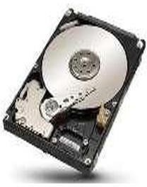

##### Fig 4.5 Hard Drive

1. **Memory (RAM):** Random-access memory (RAM) is a form of computer data storage that stores data and machine code currently being used. A random- access memory device allows data items to be read or written in almost the same amount of time irrespective of the physical location of data inside the memory. In today's technology, random-access memory takes the form of integrated chips. RAM is normally associated with volatile types of memory (such as DRAM modules), where stored information is lost if power is removed, although non- volatile RAM has also been developed. A minimum of 4 GB RAM is recommended for the proposed system.

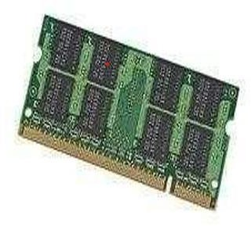

##### Fig 4.6 RAM

* 1. **SOFTWAREREQUIREMENTS**

The software requirements are description of features and functionalities of the target system. Requirements convey the expectations of users from the software product. The requirements can be obvious or hidden, known or unknown, expected or unexpected from client ‘s point of view.

1. **VS CODE:** At its heart, Visual Studio Code features a lightning-fast source code editor, perfect for day-to-day use. With support for hundreds of languages, VS Code helps you be instantly productive with syntax highlighting, bracket-matching, auto-indentation, box selection, snippets, and more. Intuitive keyboard shortcuts, easy customization and community- contributed keyboard shortcut mappings let you navigate your code with ease. For serious coding, you'll often benefit from tools with more code understanding than just blocks of text. Visual Studio Code includes built-in support for IntelliSense code completion, rich semantic code understanding and navigation, and code refactoring. And when the coding gets tough, the tough get debugging. Debugging is often the one feature that developers miss most in a leaner coding experience, so we made it happen. Visual Studio Code includes an interactive debugger,

so you can step through source code, inspect variables, view call stacks, and execute commands in the console. VS Code also integrates with build and scripting tools to perform common tasks making everyday workflows faster. VS Code has support for Git so you can work with source control without leaving the editor including viewing pending changes diffs.



##### Fig 4.7 VS CODE

1. **Python:** It is an object-oriented, high-level programming language with integrated dynamics estimates primarily for web and app development. It is extremely attractive in the field of Rapid Application Development because it offers dynamic typing and dynamic binding options. Python is relatively simple, so it's easy to learn since it requires a unique syntax that focuses on readability. Developers can read and translate Python code much easier than other languages. In turn, this reduces the cost of program maintenance and development because it allows teams to work collaboratively without significant language and experience barriers. Additionally, Python supports the use of modules and a package, which means that programs can be designed in a modular style and code can be reused across a variety of projects.



**Fig 4.8 Python**

### CHAPTER 5

**SYSTEMDESIGN**

#### 5.1 Data Flow Diagrams

Data flow diagrams are used to graphically represent the flow of data in a business information system. DFD describes the processes that are involved in a system to transfer data from the input to the file storage and reports generation. Data flow diagrams can be divided into logical and physical. The logical data flow diagram describes flow of data through a system to perform certain functionality of a business. The physical data flow diagram describes the implementation of the logical data flow.

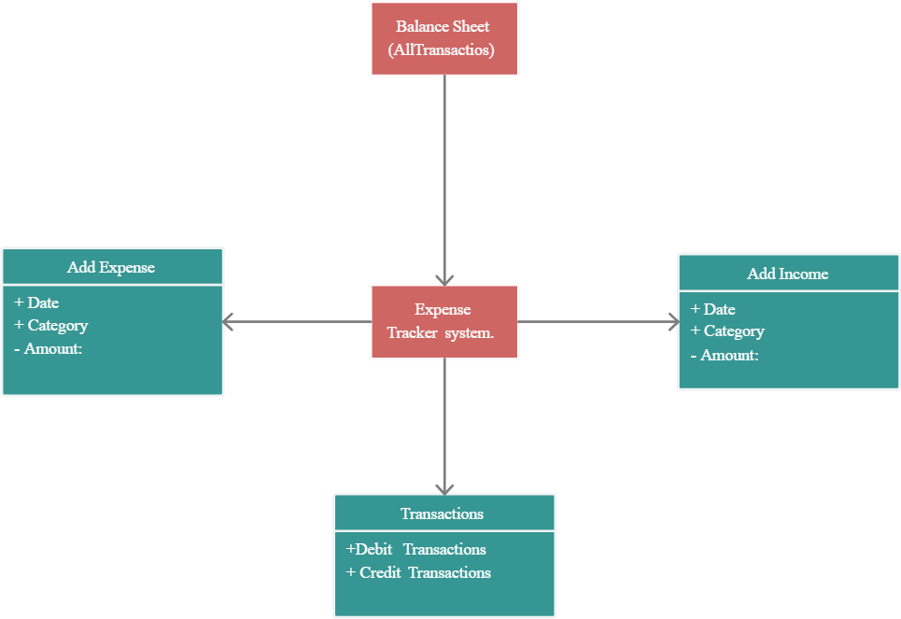

##### Fig 5.2 Data Flow Diagram

**5.3 Sequence Diagram**

Sequence Diagrams are interaction diagrams that detail how operations are carried out. They capture the interaction between objects in the context of a collaboration. Sequence Diagrams are time focus and they show the order of the interaction visually by using the vertical axis of the diagram to represent time what messages are sent and when the response is accessed.

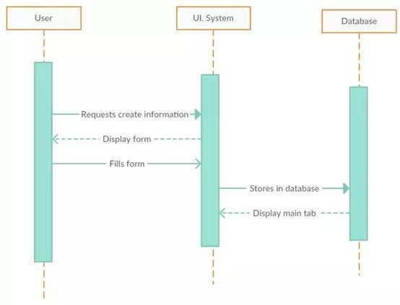

##### Fig 5.3 Sequence Diagram

**5.4 Use Case Diagram**

Use-case diagrams describe the high-level functions and scope of a system. These diagrams also identify the interactions between the system and its actors. Use-case diagrams illustrate and define the context and requirements of either an entire system or the important parts of the system.

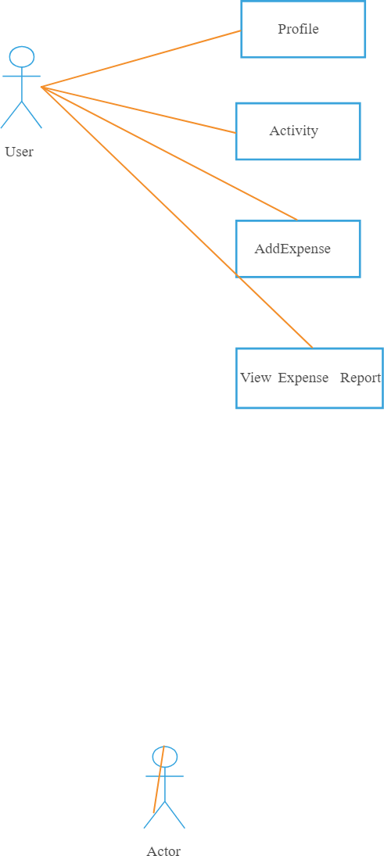

**Fig 5.4 Use Case Diagram**

### CHAPTER 6

**METHODOLOGY**

Expense management refers to the systems deployed by a business to process, pay, and audit employee-initiated expenses. These costs include, but are not limited to, expenses incurred for travel and entertainment. Expense management includes the policies and procedures that govern such spending, as well as the technologies and services utilized to process and analyses the data associated with it. Software to manage the expense claim, authorization, audit and repayment processes can be obtained from organizations that provide a licensed software, implementation and support service, or alternatively, from software as a service (SaaS) provider. SaaS providers offer on-demand web-based applications managed by a third party to improve the productivity of expense management.

##### Python

Python is a [high-level](https://en.wikipedia.org/wiki/High-level_programming_language)[,](https://en.wikipedia.org/wiki/General-purpose_programming_language) [general-purpose programming language.](https://en.wikipedia.org/wiki/General-purpose_programming_language) Its design philosophy emphasizes code readabilit[y](https://en.wikipedia.org/wiki/Code_readability) with the use of significant indentatio[n.](https://en.wikipedia.org/wiki/Off-side_rule) Python is [dynamically](https://en.wikipedia.org/wiki/Type_system#DYNAMIC) [typed](https://en.wikipedia.org/wiki/Type_system#DYNAMIC) and [garbage-collected.](https://en.wikipedia.org/wiki/Garbage_collection_(computer_science))

Python includes the policies and procedures that govern such spending it supports multiple paradigms, including [structured](https://en.wikipedia.org/wiki/Structured_programming) [,](https://en.wikipedia.org/wiki/Structured_programming) object oriented and [functional](https://en.wikipedia.org/wiki/Functional_programming) [programming.](https://en.wikipedia.org/wiki/Functional_programming) It is often described as a "batteries included" language due to its comprehensive [standard library.](https://en.wikipedia.org/wiki/Standard_library) [Guido van Rossum](https://en.wikipedia.org/wiki/Guido_van_Rossum) began working on Python in the late 1980s as a successor to the [programming language](https://en.wikipedia.org/wiki/ABC_(programming_language)) and first released it in 1991 as was released in 2000. Python 3.0, released in 2008, was a major revision not completely [backward-](https://en.wikipedia.org/wiki/Backward_compatibility) [compatible](https://en.wikipedia.org/wiki/Backward_compatibility) with earlier versions. Python 2.7.18, released in 2020, was the last release of Python 2. Python consistently ranks as one of the most popular programming languages, and has gained widespread use in the [machine](https://en.wikipedia.org/wiki/Machine_learning) [learning](https://en.wikipedia.org/wiki/Machine_learning) community.

**Readable Syntax:** Python's syntax is clear and easy to understand, which makes it a good choice for beginners.

**Dynamic Typing:** You don't need to declare variable types explicitly; Python determines the type at runtime**.**

**Interpreted:** Python code is executed line-by-line, which makes debugging easier.

**Extensive Libraries:** Python has a rich set of libraries and frameworks for various applications, from web development to data analysis.

**Community Support:** A large and active community contributes to a wealth of resources and tools.

##### Basic Terminology

* + - Dataset: A set of data examples, which contain features important to solving the problem.
    - Features: Important pieces of data that help us understand a problem. These are fed into a python language to help it learn
    - Model: The representation (internal model) of a phenomenon that a python language has learnt. It learns this from the data it is shown during training. The model is the output you get after training an algorithm.

##### 6.1 Types

**Spreadsheets:** Spreadsheets can be an easy, cheap way to keep track of expenses, but they still have paper receipts that go along with them that can be lost or damaged. This can also be a labour-intensive method and it can be confusing if employees are not good at using spreadsheets.

**Paper forms:** Paper forms work well with paper receipts. This is also an inexpensive way to manage expense reports. However, this can amount to a lot of manual work of logging and tracking these reports for both employees, approvers, and the people who need to pay the bills in the accounting department.

**Software:** Software reduces the workload, but it also can cost more in the beginning to implement. According to the Aberdeen Group's report, "Best-In-Class T&E Expense Management software can solve the major problems of compliance, manual labour, approval time, and the cost of expense reporting overall.

## CHAPTER 7

**SYSTEM IMPLEMANTATION**

### 7.1 INTRODUCTION

Implementation stage is where we convert our design into a working real-world system. We need to put together all the details we collected in the requirements and design stage and device a plan to give shape to our system. By incorporating all the designs and requirements we can start our implementation of the system by coding the entire system according to the architecture and the various functions and system properties we devised in the sequence diagrams as well as ensure all the use cases can be incorporated in the systems implementation. The implementation of the project begins with the installation of the required software on a System having the basic required hardware as discussed in chapter 3.

##### Step-by-step implementation:

1. **Setup Django Project and Environment:**
   * Install Django using pip (pip install Django).
   * Create a new Django project (Django-admin start project expense _management

_system).

* + Navigate into the project directory (cd expense _management _system).

##### Create Django App for Expenses:

Generate a Django app for managing expenses (python manage.py start app expenses).

##### Define Expense Model:

Define a model in expenses/models.py for expenses, including fields like date, amount, category, description, status, and a ForeignKey to link expenses to users.

##### Implement Django Views:

* Develop views in expenses/views.py for CRUD operations:
* List all expenses (expense list).
* Display individual expense details
* Create new expenses (expense create).
* Update existing expenses (expense update)

##### Create Expense Forms

* + Define Django forms in expenses/forms.py for creating and updating expense entries.

##### Configure URLs

* + Define URL patterns in expenses/urls.py to map views to URL endpoints for navigation and interaction.

##### Design Templates

* + Create HTML templates in expenses/templates/expenses/ to render user interfaces for expense-related views: o List of expenses (expense_list.html). o Detail view of an expense (expense_detail.html). o Form for creating/editing expenses

(expense_form.html). o Confirmation page for deleting expenses (expense_confirm_delete.html).

##### Implement User Authentication

* + Utilize Django’s built-in authentication system to control access and permissions for expense-related actions.

##### Run Migrations and Start Development Server

* + Apply migrations to create database tables (python manage.py make migrations and python manage.py migrate).
  + Start the Django development server to test locally (python manage.py run server).

## CHAPTER 8

**RESULTS**

#### Experimental Results

In this section we will be discussing the results of our implementation and display the snapshots of the application that has been developed. How each module that we discussed in the implementation will be represented and how the expected results are obtained. The app that has been developed can be shown with a screenshot and how the interactions happen. But the working of the model cannot be displayed in this report.

##### Home Page



**Fig 8.1 Home page**

The homepage of this system should be designed with a focus on usability, clarity, and simplicity. Here are some suggestions.

##### Add Expenses

**Fig 8.2 Add Expenses**

Here we adding an expense, it's important to document essential details such as the amount spent, date of the transaction, and a brief description of the purchase or service obtained.

##### Adding Expenses of the day

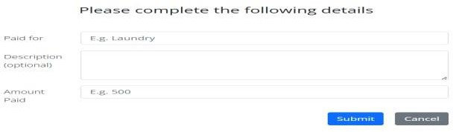

**Fig 8.3 Add Expenses of the day**

Expenses encompass various categories such as housing, utilities, transportation, groceries, healthcare, and discretionary spending on entertainment and dining out.

##### Expenses are added to the list

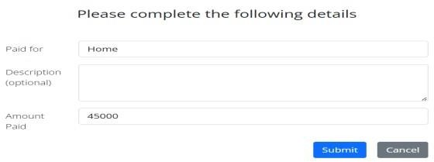

**Fig 8.4 Expenses are added to the list**

This approach ensures that individuals maintain control over their finances, optimize their budgeting efforts, and work towards achieving greater financial stability and security.

##### Viewing the details of added expenses

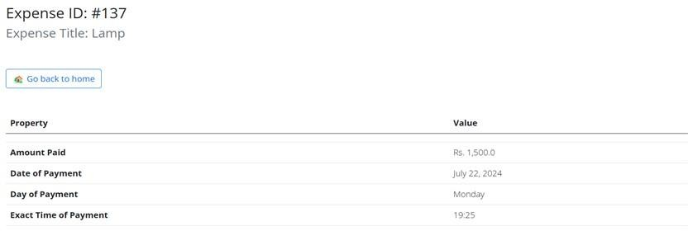

**Fig 8.5details of added expense**

Viewing the details of added expenses involves accessing comprehensive information about each expenditure, including the amount spent, date of purchase, and specific category under which it was recorded.

#### Past month expense details

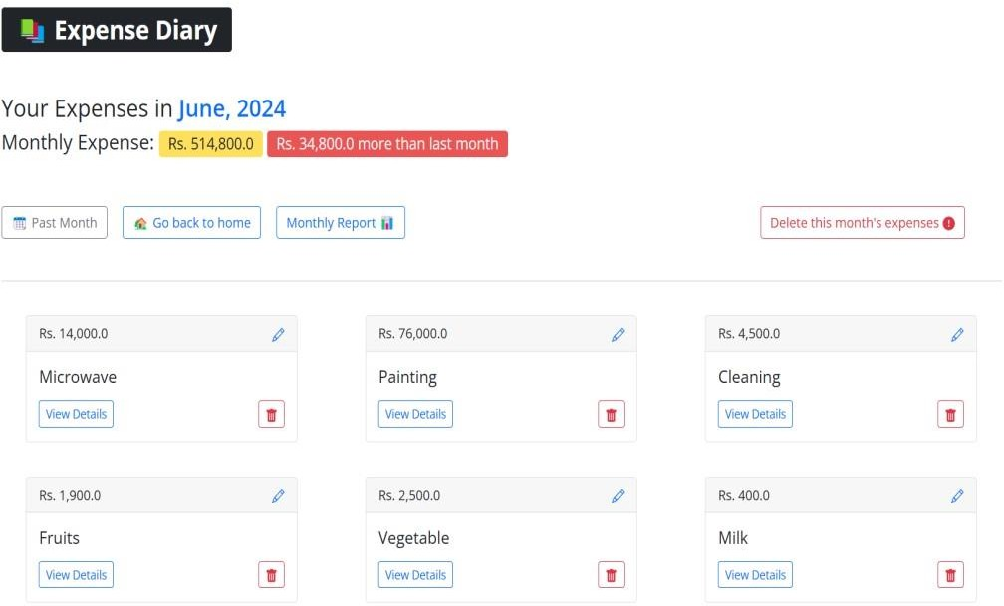

##### Fig 8.6 Past month expense details

Here reviewing the past month's expense details provides a comprehensive snapshot of how money was spent over that period.

#### Last month expense can be deleted

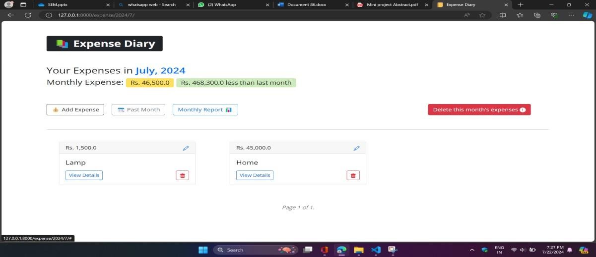

##### Fig 8.7Monthly expense deleted

Monthly expense deleted refers to the removal or deletion of recorded expenses from a financial record or system. This could occur due to various reasons such as data entry errors, corrections, or adjustments in accounting procedures.

#### Monthly report can be viewed

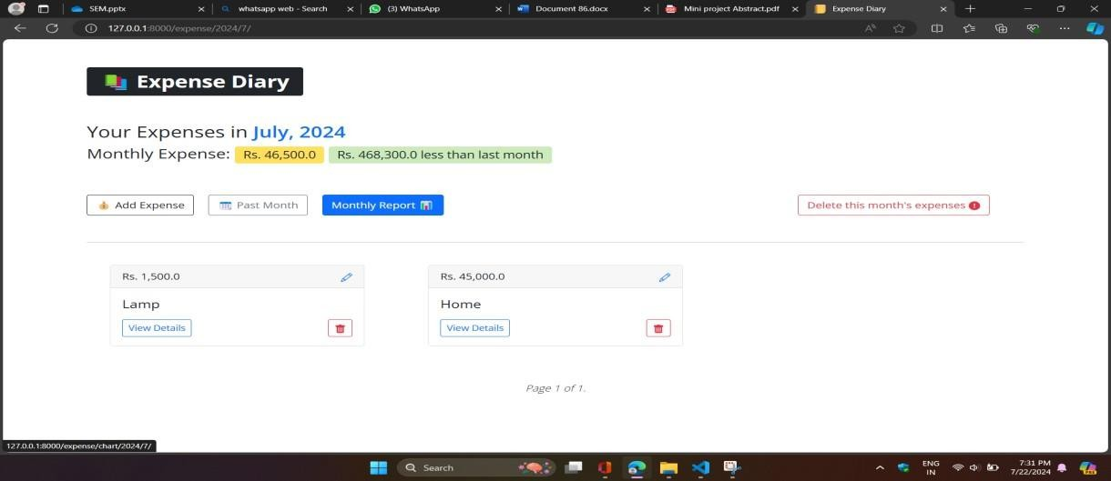

##### Fig 8.8 Monthly report viewed

Its purpose is to facilitate informed decision-making and strategic planning based on current performance insights.

#### Go back to home is displayed

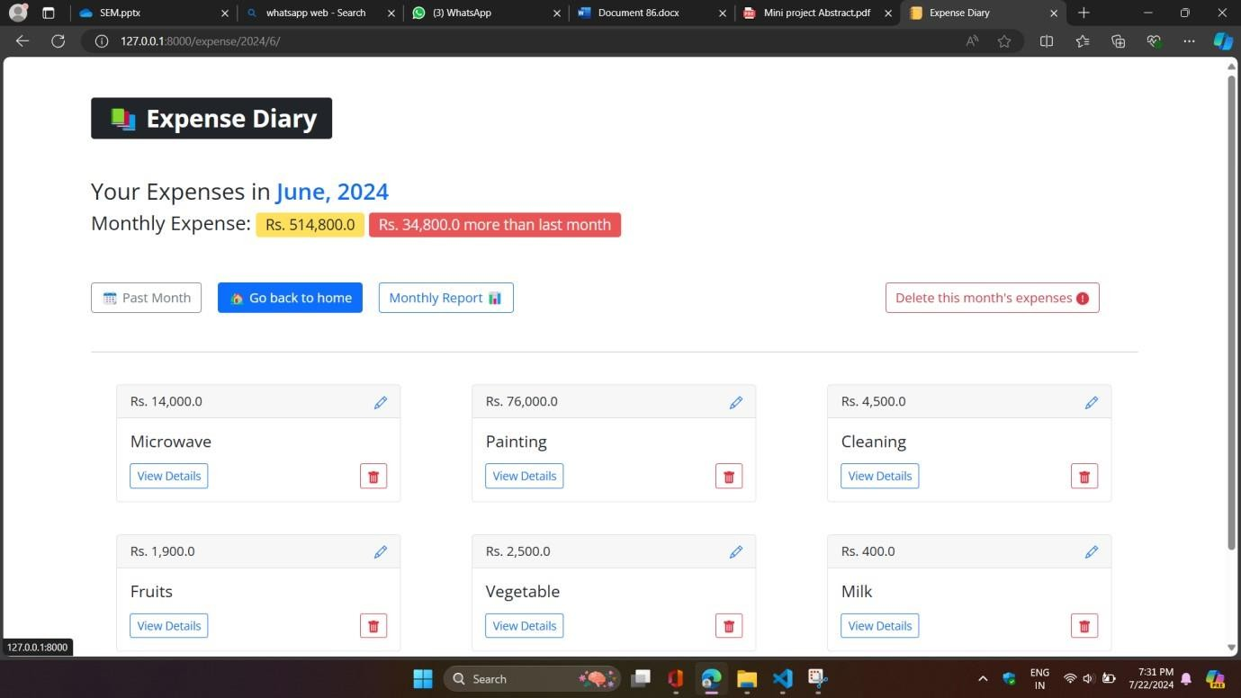

##### Fig 8.9Go back to home page

The homepage of a website typically serves as the main entry point, welcoming visitors and providing an overview of what the site offers.

* + 1. **Monthly report of the expenses**

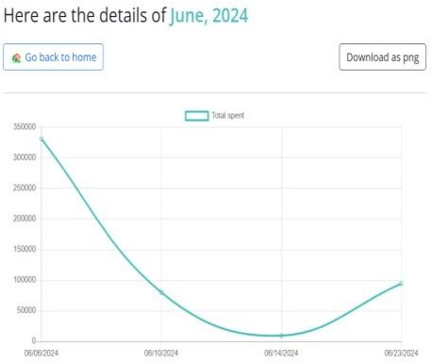

##### Fig 8.10 Monthly report of the expenses

A monthly report of expenses provides a comprehensive overview of financial outflows incurred over a specific month. It typically includes detailed breakdowns of expenditures across various categories.

#### listed expense can be deleted separately

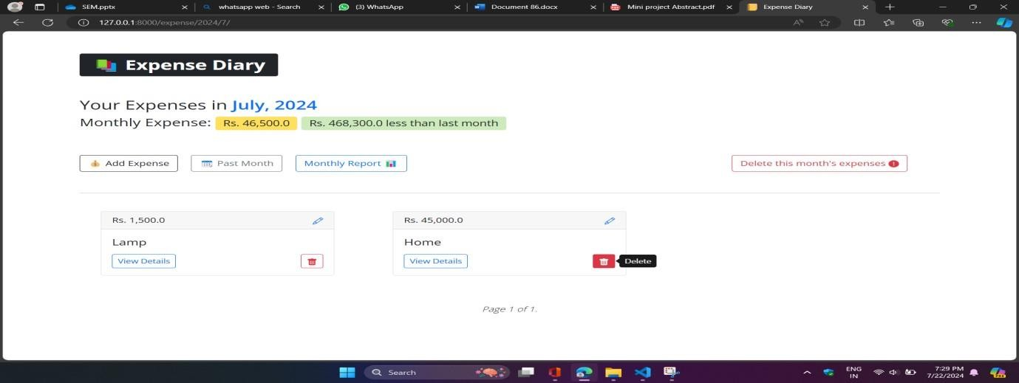

##### Fig 8.11 Expenses deleted separately

If expenses have been deleted separately, it typically refers to the removal or loss of detailed records or entries related to spending or costs.

#### Viewing the details added expenses

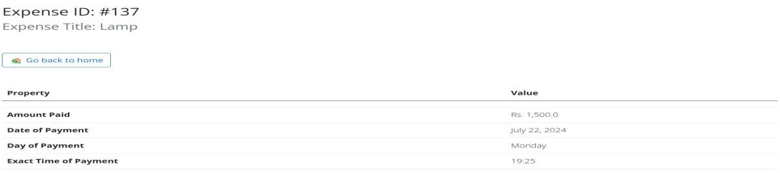

##### Fig 8.12 Details of added expenses

details of added expenses it generally refers to providing specific information about newly incurred costs or expenditures. This includes documenting the date, amount, purpose, and category of each expense.

#### Expenses can be updated

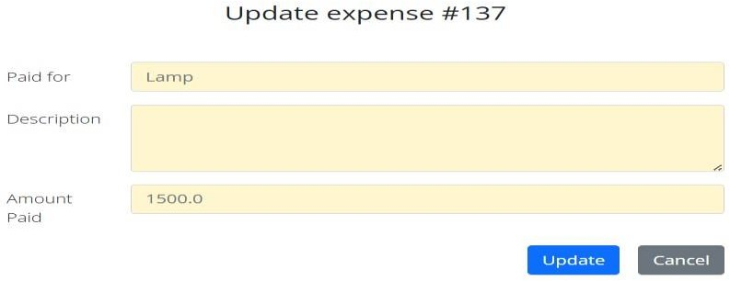

##### Fig 8.13 Updated expenses

Updated expenses typically refer to a revised or current list of expenditures that reflects recent transactions or changes in financial records. This includes capturing any new expenses incurred since the last update, documenting them with details such as date, amount, purpose, and category.

#### Download the chart in png form



##### Fig 8.14 Download the chart in png form

To download the chart in PNG form, typically you would find an option on a website or application that allows you to save the visual representation as an image file.

### CONCLUSION

In daily life, effective expense management plays a crucial role in maintaining financial stability and achieving personal financial goals. By diligently tracking daily expenses such as groceries, transportation, dining out, and other discretionary spending, individuals can gain a clear understanding of their cash flow and identify areas where adjustments may be needed to stay within budgetary limits. This daily monitoring helps in making informed spending decisions and avoiding unnecessary expenditures, ultimately contributing to better financial discipline.

### REFERENCES

##### Books:

1. The Red Book –OpenGL Programming Guide,6th edition.
2. Rost , Randi J. : OpenGL Shading Language, Addison-Wesley
3. Interactive Computer Graphics-A Top Down Approach Using OpenGL, Edward Pearson-5th edition.

##### Websites:

1. <http://www.opengl.org/documentation>
2. <http://www.nehe.gamedev.net/lesson.asp?index=01>
3. <http://en.wikipedia.org/wiki/OpenGL#Documentation>